# DAD Distinction Task – Template

Student ID 103542974

Name: Hai Hoang Le

## **Part 1 ERDs and Schemas**

### Narrative 1 ERD

Paste your ERD here

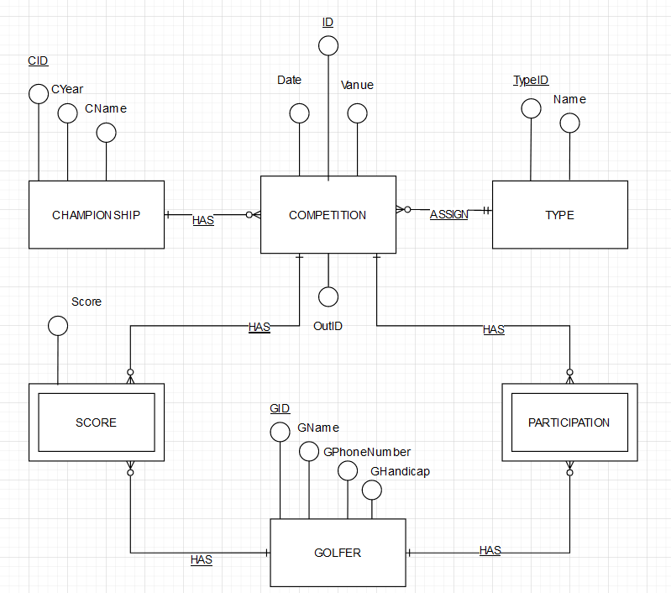

### Narrative 1 Schema

Paste your Schema here

CHAMPIONSHIP (CID, CYear, CName)

PK (CID)

TYPE (TypeID, Name)

PK (TypeID)

COMPETITION (ID, Date, Vanue, OutID, CID, TypeID)

PK (ID, CID, TypeID)

FK1 CID references CHAMPIONSHIP (CID)

FK2 TypeID references TYPE(TypeID)

GOLFER (GID, GName, GPhoneNumber, GHandicap)

PK (GID)

PARTICIPATION (ID, GID)

PK(ID, GID)

FK1 ID references COMPETITION (ID)

FK2 GID references GOLFER(GID)

SCORE(ID, GID, Score)

PK(ID, GID)

FK1 ID references COMPETITION (ID)

FK2 GID references GOLFER(GID)

### Narrative 2 ERD

Paste your ERD here

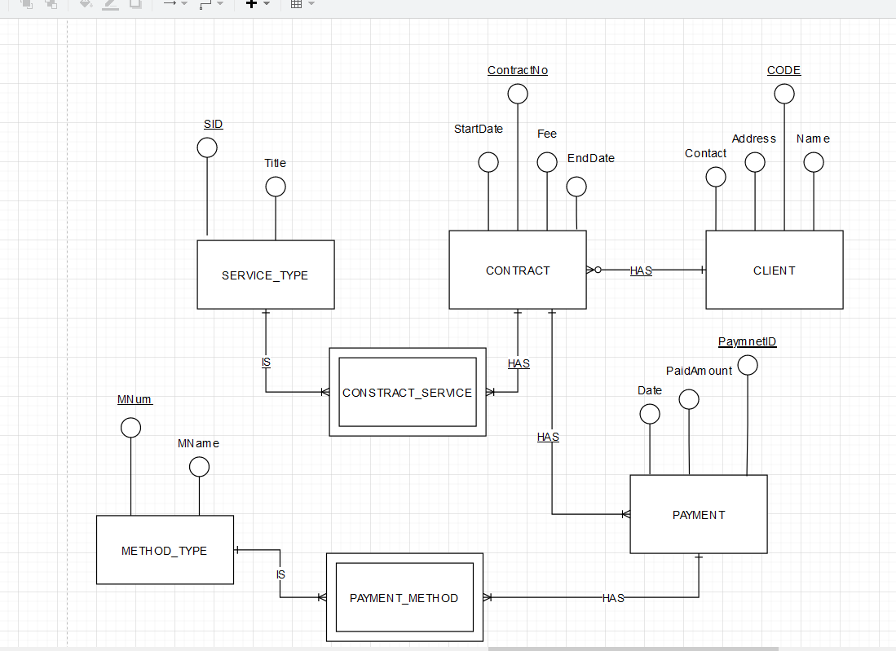

### Narrative 2 Schema

Paste your Schema here

SERVICE_TYPE (SID, Title)

PK (SID)

CLIENT (CODE, Contact, Address, Name)

PK (CODE)

CONTRACT (ContractNo, StartDate, EndDate, Fee, CODE)

PK (ContractNo)

FK CODE references CLIENT (CODE)

CONTRACT_SERVICE (SID, ContractNo)

PK (ContractNo, SID)

FK1 SID references SERVICE_TYPE (SID)

FK2 ContractNo references CONTRACT(ContractNo)

METHOD_TYPE (MNum, MName)

PK (MNum)

PAYMENT (PaymnetID, PaidAmount, Date, ContractNo)

PK ( PaymentID, ContractNo)

FK ContractNo references CONTRACT(ContractNo)

PAYMENT_METHOD ( MNum, PaymentID)

PK (MNum, PaymentID)

FK1 MNum references METHOD_TYPE (MNum)

FK2 PaymentID references PAYMENT(PaymnetNo)

## **Part 2 Building Database**

Design Views and Datasheet views of 3 Tables created here.

AgeCategory Table

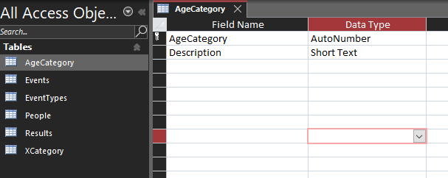

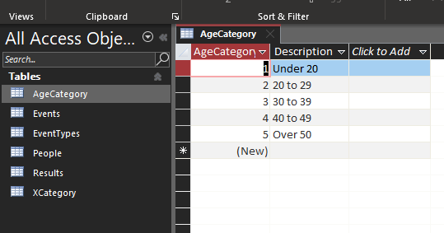

EventTypes Table

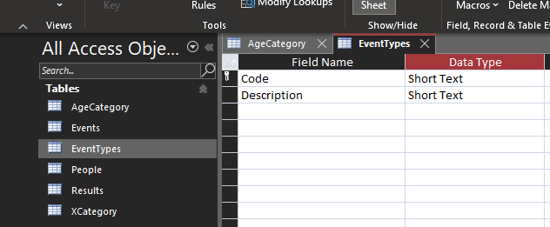

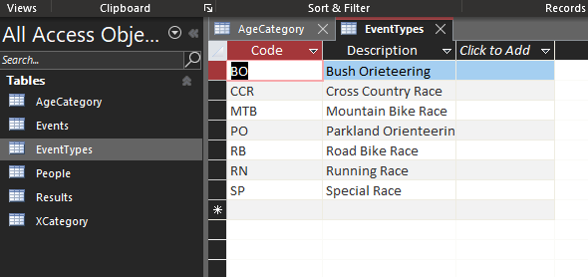

XCategory Table

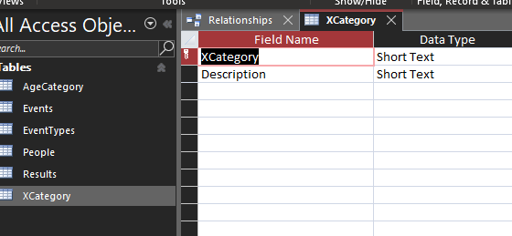

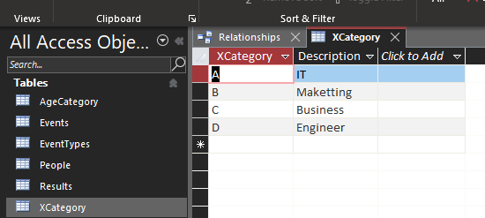

## **Part 3. Queries and Insert Data**

### Q1. People Query

### Design:

Paste screen design captures here

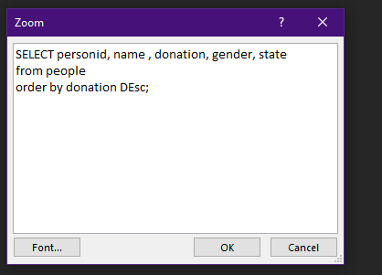

### Result Set:

Paste screen design captures here

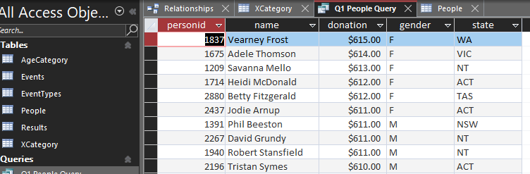

## Q2. Donation

### Design:

Paste screen design captures here

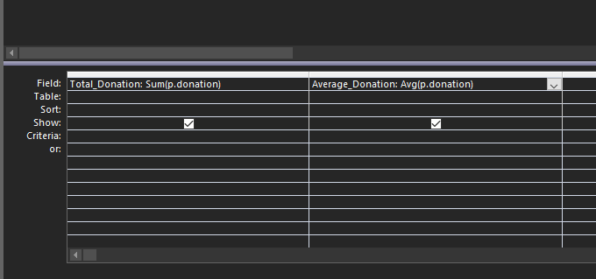

### Result Set:

Paste screen design captures here

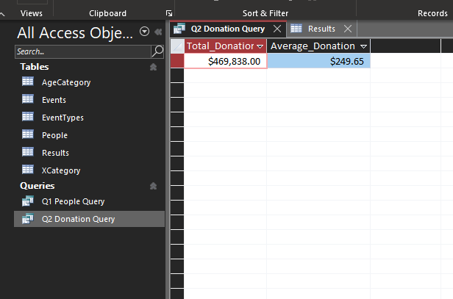

## Q3. Gender

### Design:

Paste screen design captures here

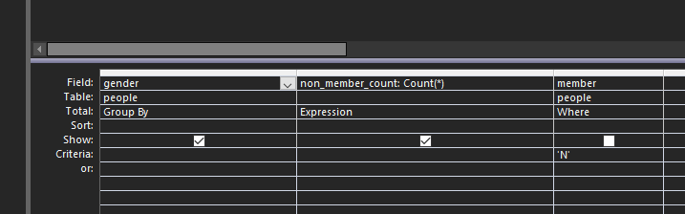

### Result Set:

Paste screen design captures here

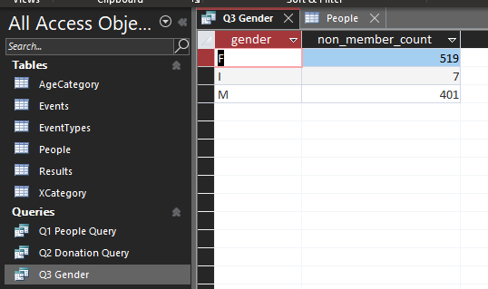

## Q4. Fastest

### Design:

Paste screen design captures here

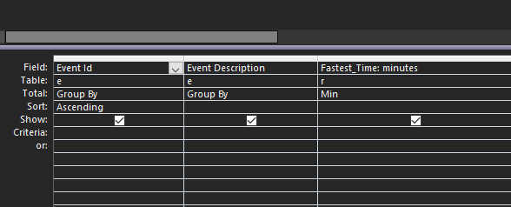

### Result Set:

Paste screen design captures here

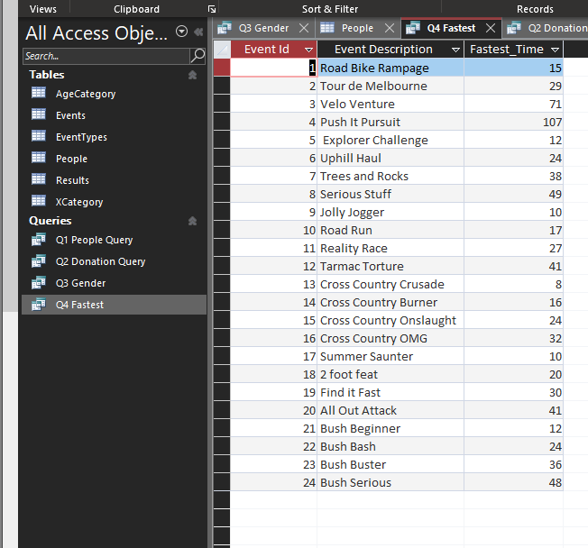

## Q5. Better than Average

### Design:

Paste screen design captures here

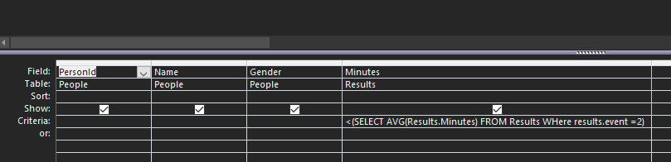

### Result Set:

Paste screen design captures here

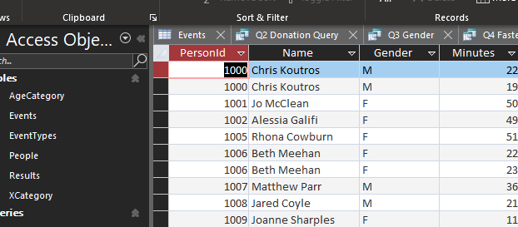

## Q6. Persons with No Results

### Design:

Paste screen design captures here

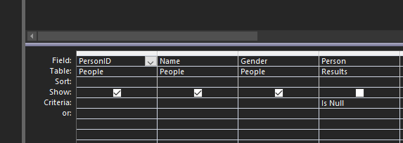

### Result Set:

Paste screen design captures here

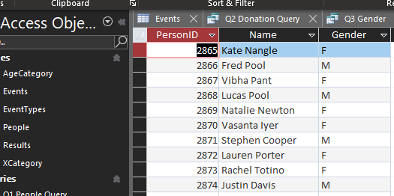

## Q7. XCategory

### Design:

Paste screen design captures here

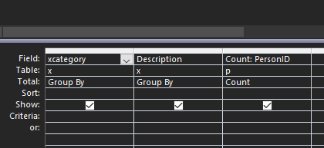

### Result Set:

Paste screen design captures here

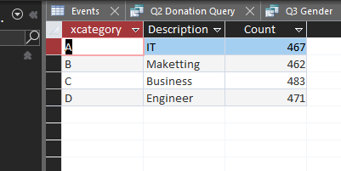

## Q8. Insert Your data and Event 25

### Result Set:

Paste screen design captures here

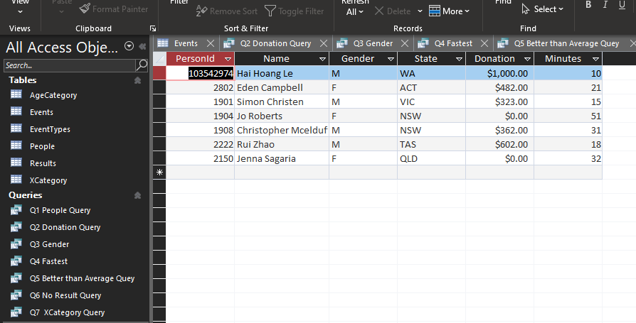

## **Part 4 Visualizations**

## Q1. Member Category Viz

### Settings:

Paste viz settings captures here

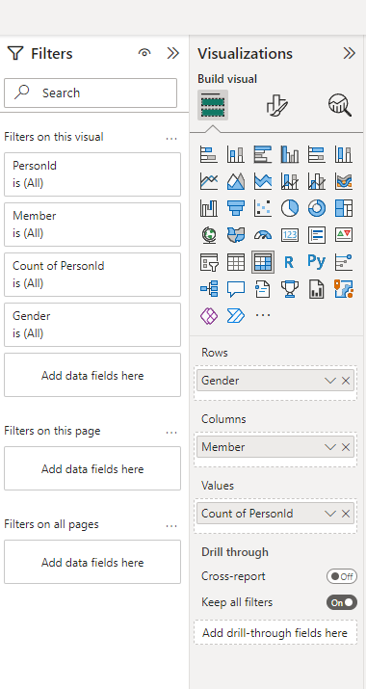

### Visualization:

Paste the visualisation capture here

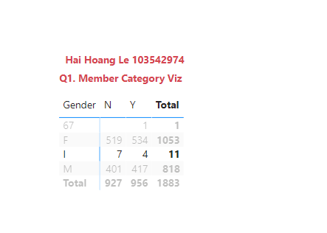

## Q2. Age Category Viz

### Settings:

Paste viz settings captures here

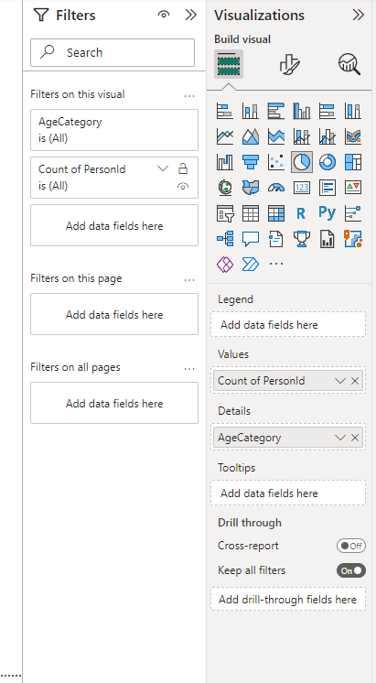

### Visualization:

Paste the visualisation capture here

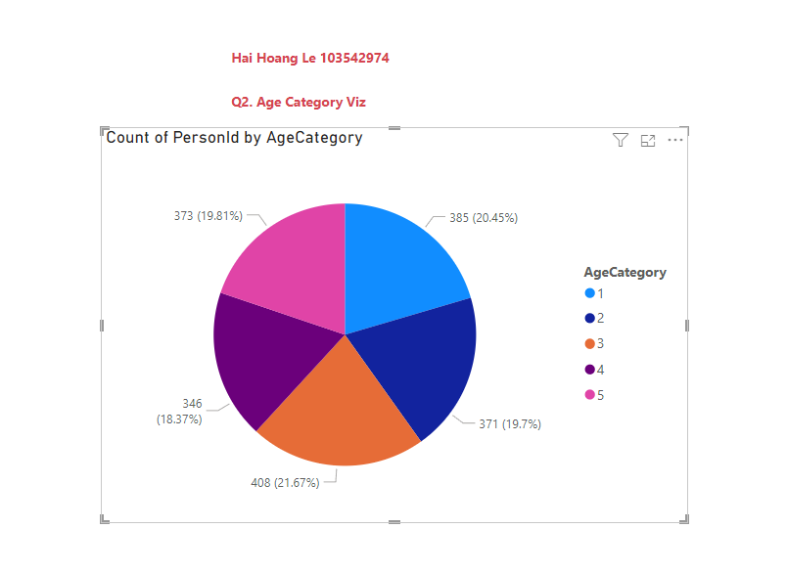

## Q3. X Category Viz

### Settings:

Paste viz settings captures here

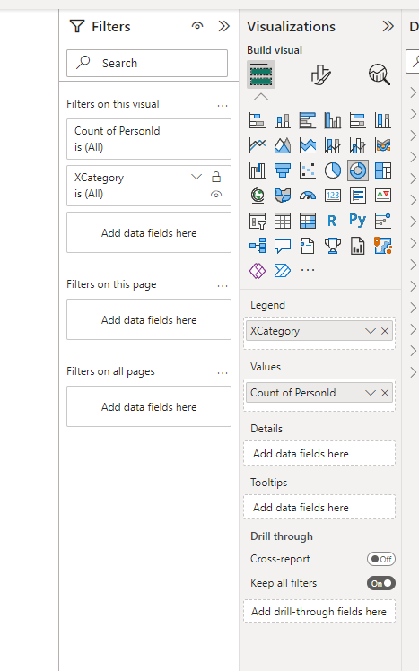

### Visualization:

Paste the visualisation capture here

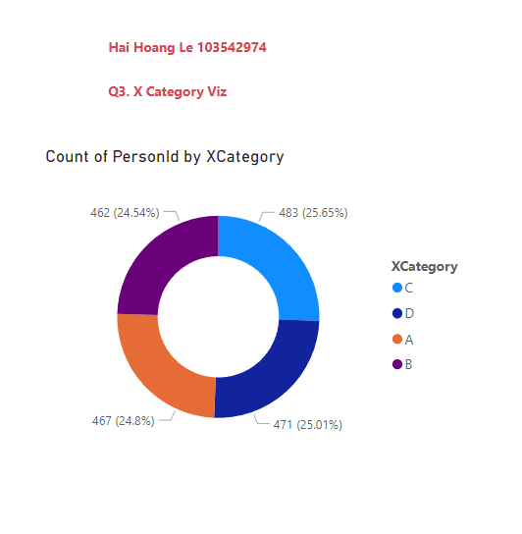

## Q4. Event Viz

### Settings:

Paste viz settings captures here

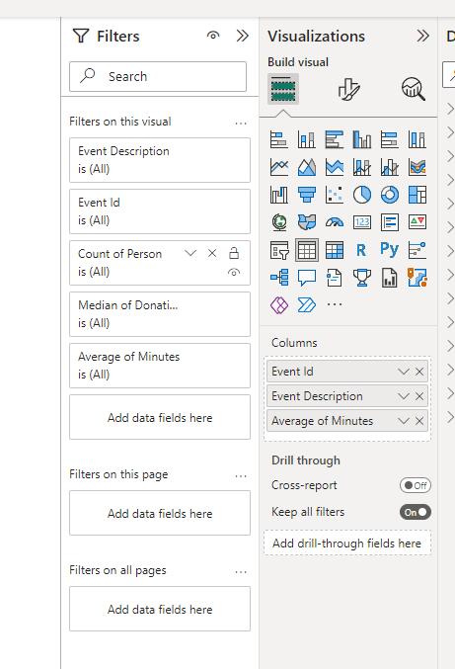

### Visualization:

Paste the visualisation capture here

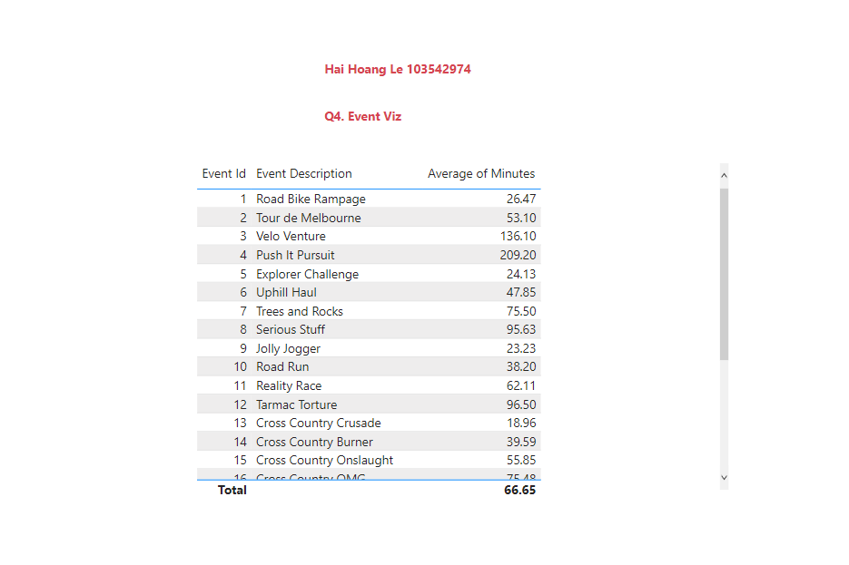

## Q5. Event 25 Viz

### Settings:

Paste viz settings captures here

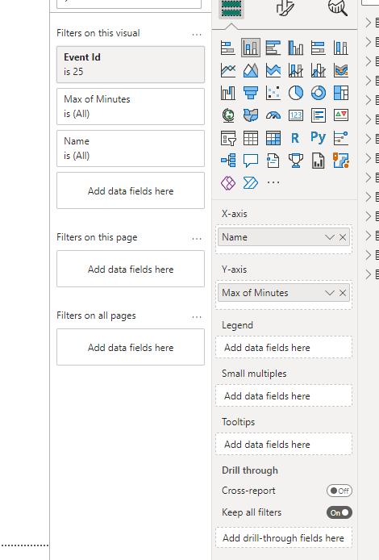

### Visualization:

Paste the visualisation capture here

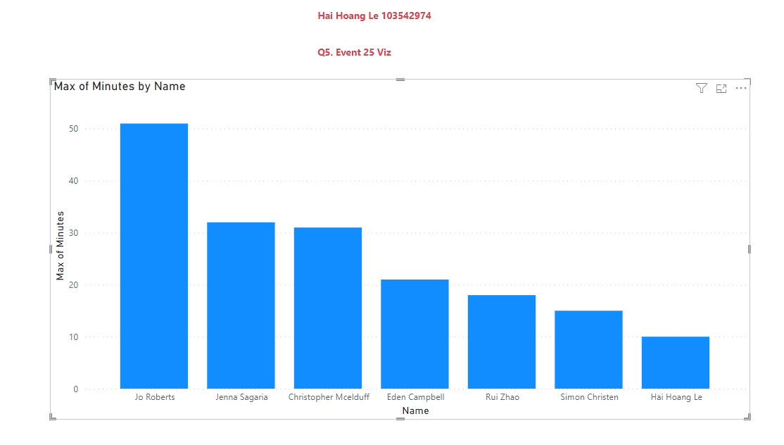

## Q6. Extra Viz 1

### Settings:

Paste viz settings captures here

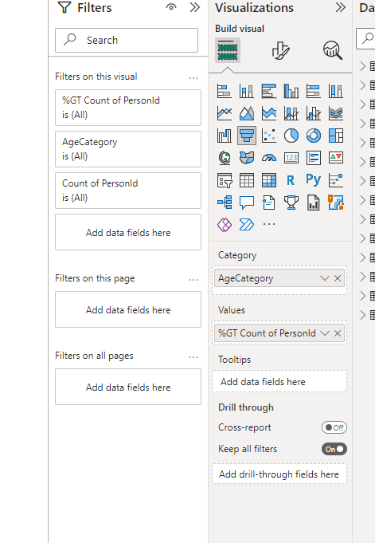

### Visualization:

Paste the visualisation capture here

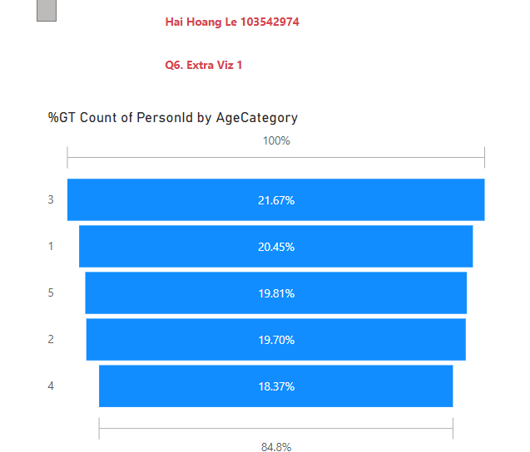

## Q7. Extra Viz 2

### Settings:

Paste viz settings captures here

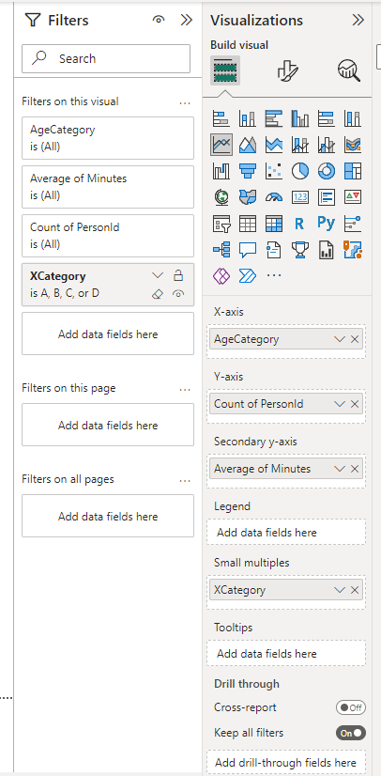

### Visualization:

Paste the visualisation capture here

